Discussion Time: 28th November 2020, 15:03 - 15:17

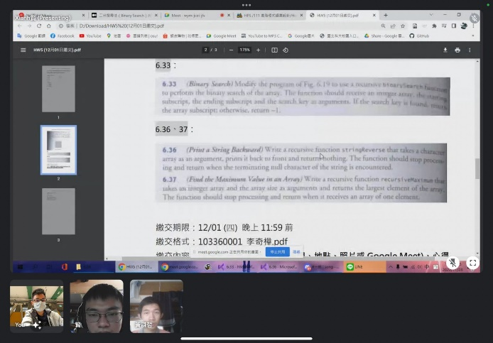

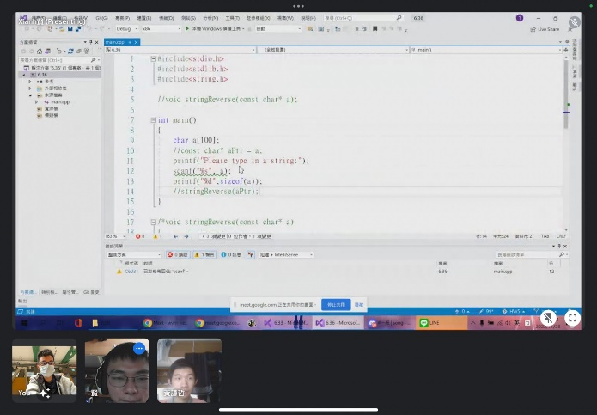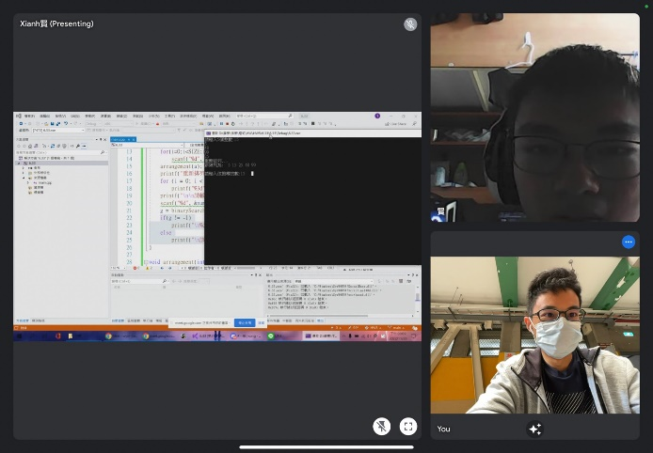

P05

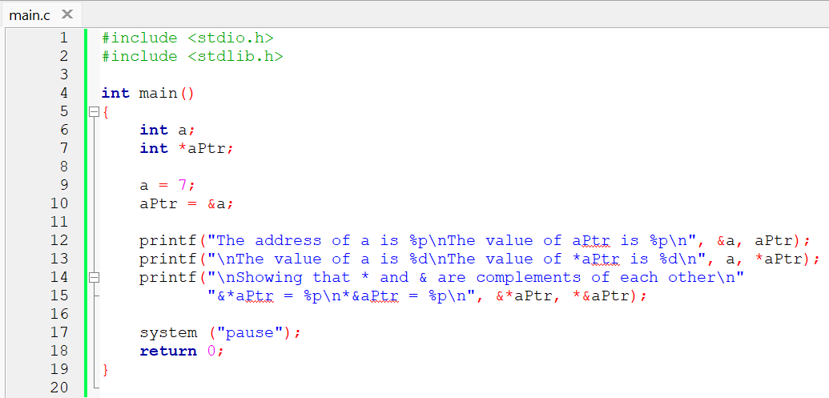

P06

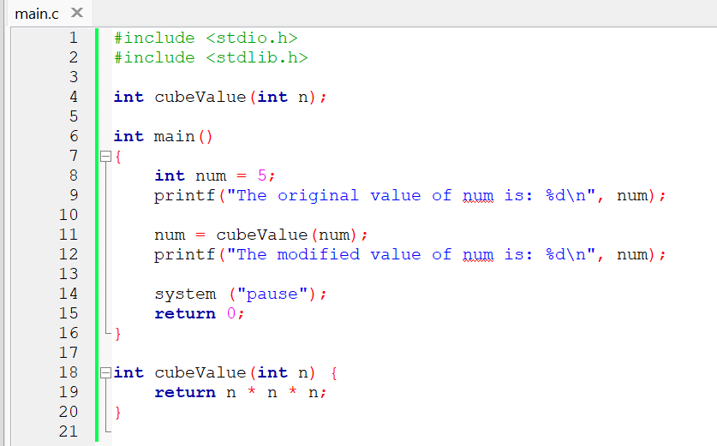

P10

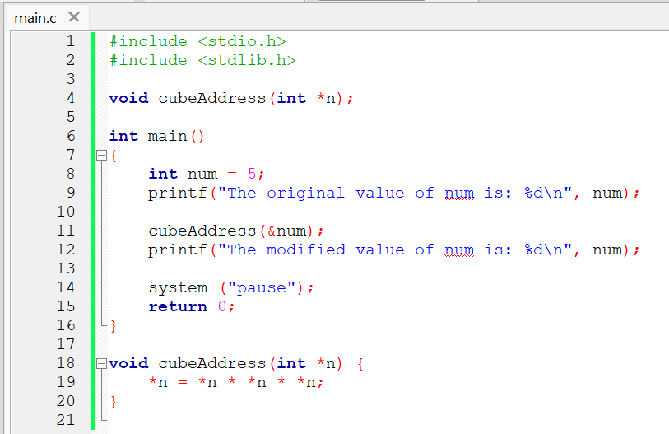

P13

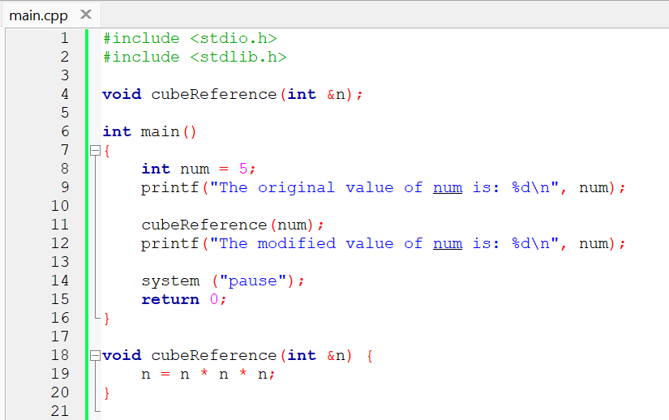

P15

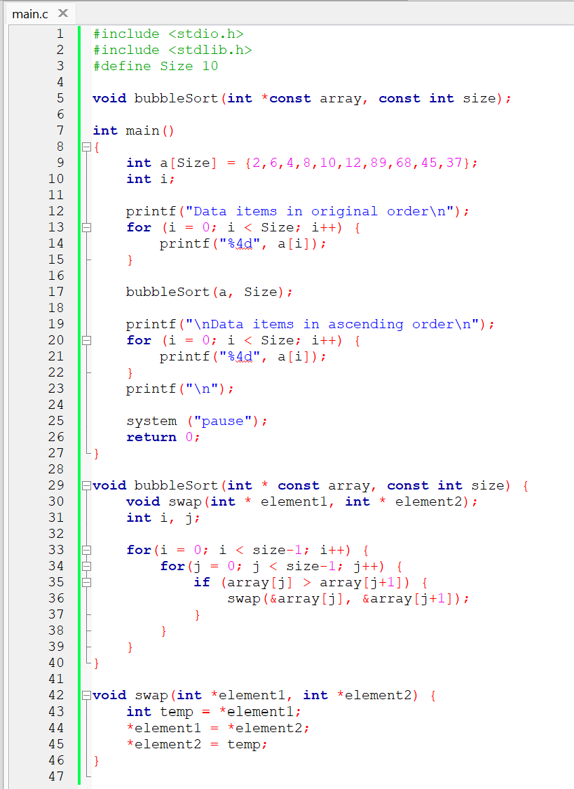

P19

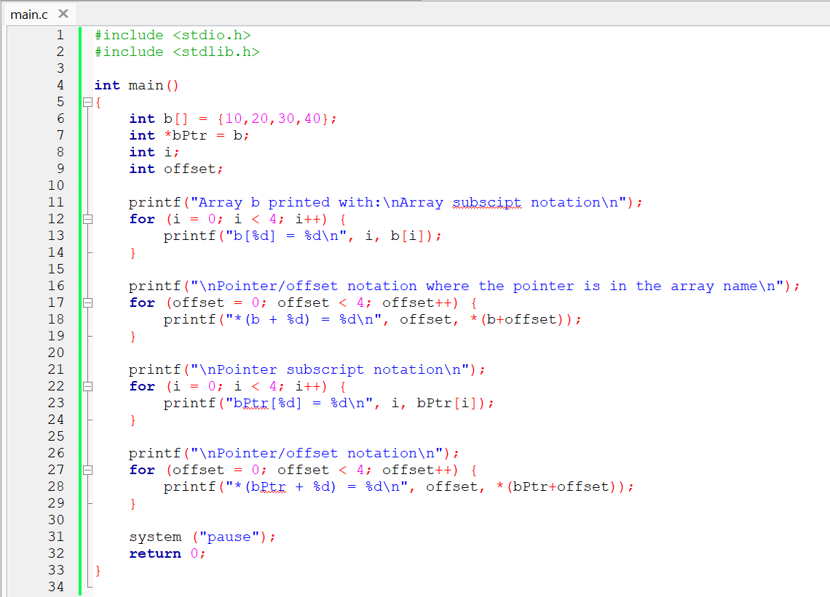

P25

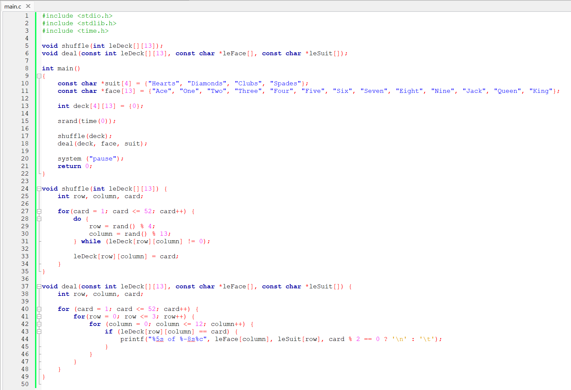

6.19

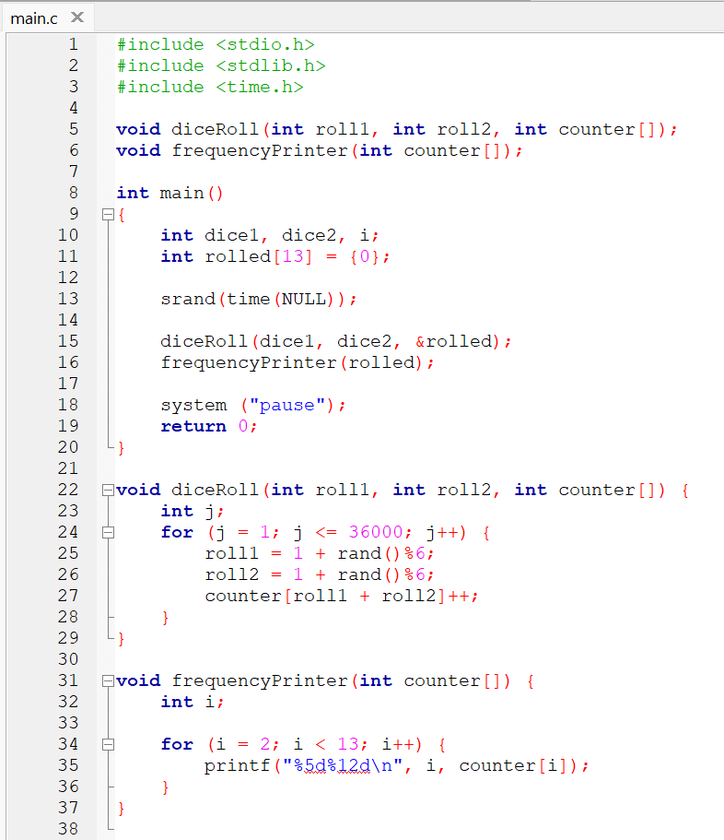

6.33

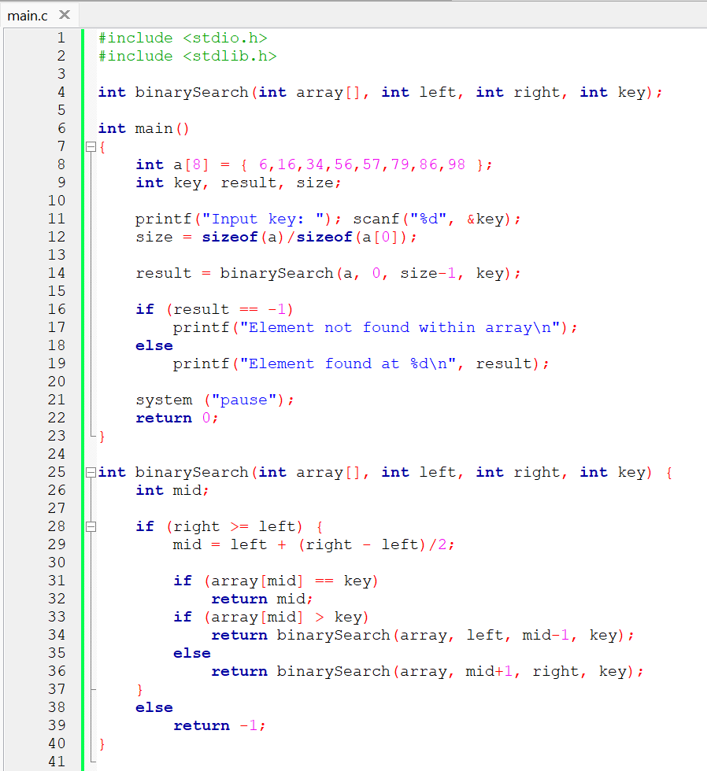

6.36

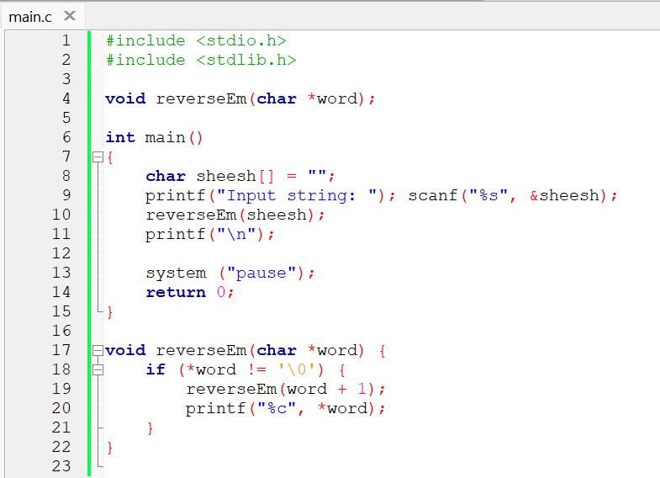

6.37

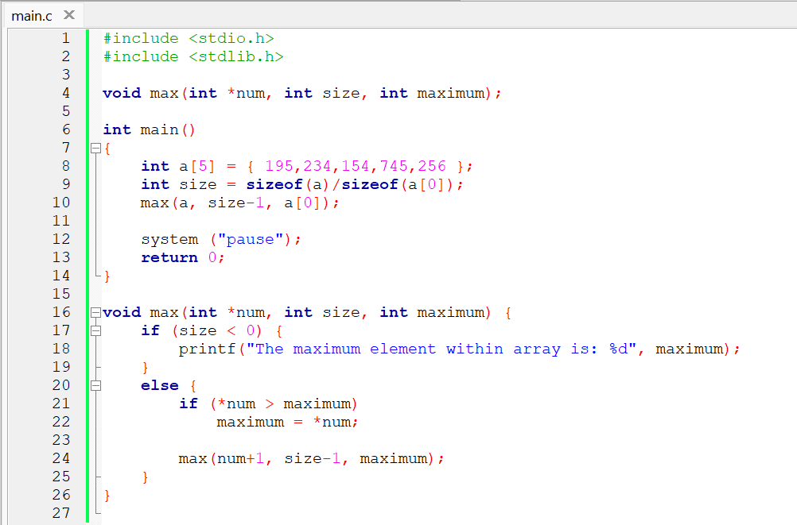

Conclusion:

The usage of pointers can simplify a program, maybe even allow certain programs to work. But the usage of pointers can make yourself confusing. Recursive function can also simplify a program, where the function calls itself. But using recursive can make one become extremely confused. For pointers, we can assign them using ‘\*’, and address can be assigned using ‘&’. Recursive is simply a function containing itself, though one needs to remember that it will become a loop, meaning it needs a terminating condition.

Code: <https://github.com/AldrichWijaya/Homework.git>